Life Finance Project
BUS 1200 Principles of Finance

Instructions:
- This is a take home project so obviously notes and books are permitted.
- This IS NOT a group project! Both Amy and the TA are willing to help. If needed, I expect you to come to us because I actually want you to LEARN what you are doing-NOT just get the correct answer.
- Do a good job. I insist.
- Show your work neatly in the space provided. Partial credit will be granted only for responses that have work clearly shown.

LATE WORK NOTICE
Assignments turned in after the due date will receive the following point deductions: 30pts day 1, 50pts day 2, and 60pts day 3. NO WORK WILL BE ACCEPTED MORE THAN 3 DAYS LATE*. Listen, if ‘the Lord disciplines those he loves’ (Proverbs 3:11-12), you better believe I will too!
*I understand things come up, so if you need extra time, PLAN AHEAD and let me know AT LEAST 24 hours in advance and I will be over-the-moon happy to work with you. “The plans of the diligent lead surely to abundance, but everyone who is hasty comes only to poverty.” Proverbs 21:5

Welp, this is it. The time has come. You have all the tools you need to develop a lifetime budget. You can do it. I believe in you. Ready (or not), here we go….

Part I: Becoming a Millionaire
You have just completed the first half of one of the most challenging yet exhilarating classes of your college career. You are 19 years old. After listening to the wise words of your awesome professor and the thrilling representatives from Calm Waters Financial, you have decided being a millionaire is well within your reach. You decide you want to be a millionaire by the age of 59. You have looked around and found a mutual fund that expects an average return of 7% compounded monthly (totally feasible). If you are making your plan today and hope to start saving at the end of the month, how much do you need to deposit each month to reach your goal?₁ How much would you end up contributing to your million?₂ After a bit of calculation, you decide you don’t want to wait until you are 59, and shift your goal to being a millionaire by 49. How much will you need to invest each month now?₃ When you see the number you realize it might be a bit to aggressive for you based on your budget. You think about it and remember that if you can find a fund yielding a high average return, you could get that payment down. You and Google have a late night together and you find a fund that averages 12% compounded monthly. What impact does that have on your monthly payment?₄ How much do you contribute with these changes?₅

Part II: Post-graduation Relaxation
Now that you have taken care of your retirement and legacy, you decide to begin planning for some much needed post-graduation relaxation. You want to fulfill a lifetime dream to backpack across Europe for a week, sleeping in hostels along the way. After carefully creating a budget, you anticipate it will cost you $3k. In addition to the $3k, you estimate needing $300 to spend on food and trinkets while you are there. If you were going to make weekly deposits into an account earning .2% per week, how much would you need to deposit each week until graduation (35 weeks)?₁
Part III: Dream Car
Now you are moving on to acquiring your dream car. You anticipate that you will land a $100K+ job because of the fantastic foundation you laid pursing a BOL degree at CIU. You can easily afford your dream car:

Just kidding! How about this:
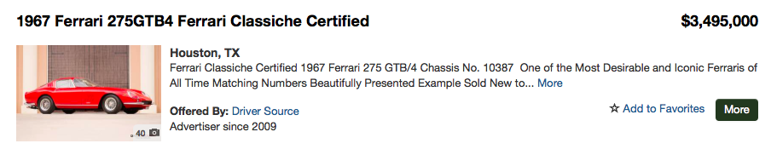
You decide $3.5 mil might be a bit over the top so you settle on your 2nd favorite:
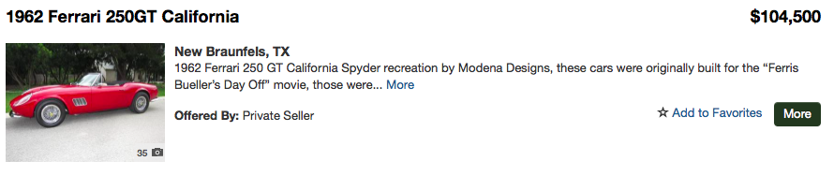
However after staring at the car and picturing yourself with your bae (yeah, I just said bae) driving down the highway you suddenly realize, with great power comes great responsibility. So you decide you should probably consider a more practical Toyota Corolla.
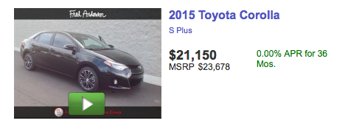
Assuming you could finance both cars at 12% compounded monthly for 5 years, you want to know the payment for each car and how much you would save each month by going with the Corolla?₁₋₃ Although you can afford both purchases, you decide you will see what would happen if you got the Toyota and invested the monthly difference. You look around and find an investment yielding .5% per month. You plan to put your money in that account for 5 years, and then at the end of year 5 move the balance to a stock account that will earn 11% compounded monthly. How much more money will you have after 5 years and in 20 years because you drove a Toyota Corolla for 5 years instead of the more expensive car?₄₋₅ What would your contribution be?₆
Part IV: Love Nest
Fast forward a few years and you have fallen in looooovvvveee…ooey gooey awesome love (like me and the world’s greatest hubs)! You get married and begin the greatest journey of your life since your salvation. You and your new spouse want to start a family. It is time to get out of the CIU apartments and put down roots. You shop around and find a home for 189,999 that you love. You feel like it is the perfect place to start your family. After looking around you find a mortgage company offering 4.75 annual percent (compounded monthly). If you do a 30-year traditional mortgage, what will your mortgage payment be*?₁ How much will you end up paying for your home?₂

You decide you want to know the difference if you went with a 15 year mortgage. The rate is actually a bit less at 4.25 annual percent (compounded monthly). What is your monthly payment now*?₃ How much will you pay over the life of your loan and how much would you save by going with a 15 year mortgage?₄₋₅ You can do the 15 year mortgage, but it will be a stretch. You wonder what would happen if you went with the 15 year mortgage and after your house was paid off you continued to make a ‘mortgage payment’ into an investment fund earning 10%. How much would you have after 30 years total (15 years of investing and 100% equity in your home!)?₆

After considering your options you believe you will go with the 30 year loan, but pay $50 extra a month. (FOR THE RECORD, ALWAYS ALWAYS GO WITH A 15 YEAR MORTGAGE-but in this case you went with the less wise option for the sake of calculating on the test). How much time will this take off of your 30-year mortgage?₇ How much will you end up saving?₈ What if you pay $150 extra a month?₉

You are about to sign the document when you grandma calls and says she wants to help you by giving you $38,000 to put as a down payment on your home. What difference does this make in your how long it takes to pay off the loan and what you end up paying for the home over the life of the loan (still assuming 30-years at $150+ additional each month vs. a 30 year traditional mortgage with no extra/mo).₁₀₋₁₁

*The mortgage payments would actually be a bit higher because of escrow. Escrow is an account set up by your lender to pay your home insurance and taxes. It is wrapped into your payment. FYI only.

Ok, now that you officially hate me…let’s begin….

PART I: Becoming a Millionaire (15 pts):

- _________________________________________

- _________________________________________

- _________________________________________

- _________________________________________

- _________________________________________

PART II: Post-Graduation Relaxation (5 pts):

- _________________________________________

PART III: Your new wheels (15 pts):

- Ferrari:_________________________________________

- Corrola:_________________________________________

- _________________________________________

- _________________________________________

- _________________________________________

- _________________________________________

PART IV: Your love nest (27 pts):

- _________________________________________

- _________________________________________

- _________________________________________

- _________________________________________

- _________________________________________

- _________________________________________

- _________________________________________

- _________________________________________

- _________________________________________

- _________________________________________

- _________________________________________

PART VI: Your answer to ‘Why is understanding Time Value of Money so important?’ AKA why should people take this class? (5 pts):

PART VII: The most important True/False Question of my-er, I mean your life (2 pts):
When I am a millionaire, I will remember the influence of my favorite finance professor and how she pushed me to start making wise financial decisions as a college student and surprise her and her husband with a European Cruise.
Circle the correct answer: TRUE or TRUE
Please sign and date the above contract answer:

Signed: __________________________________________________ Date: ____________________

BONUS (2 Points): Draw a picture of a dinosaur holding a pen OR a roller skating kangaroo

